Project Design Phase
Problem – Solution Fit

Date | 15 July 2026
Team ID | Team 1
Project Name | UNESCO World Heritage Site Analysis Using Tableau
Maximum Marks | 2 Marks

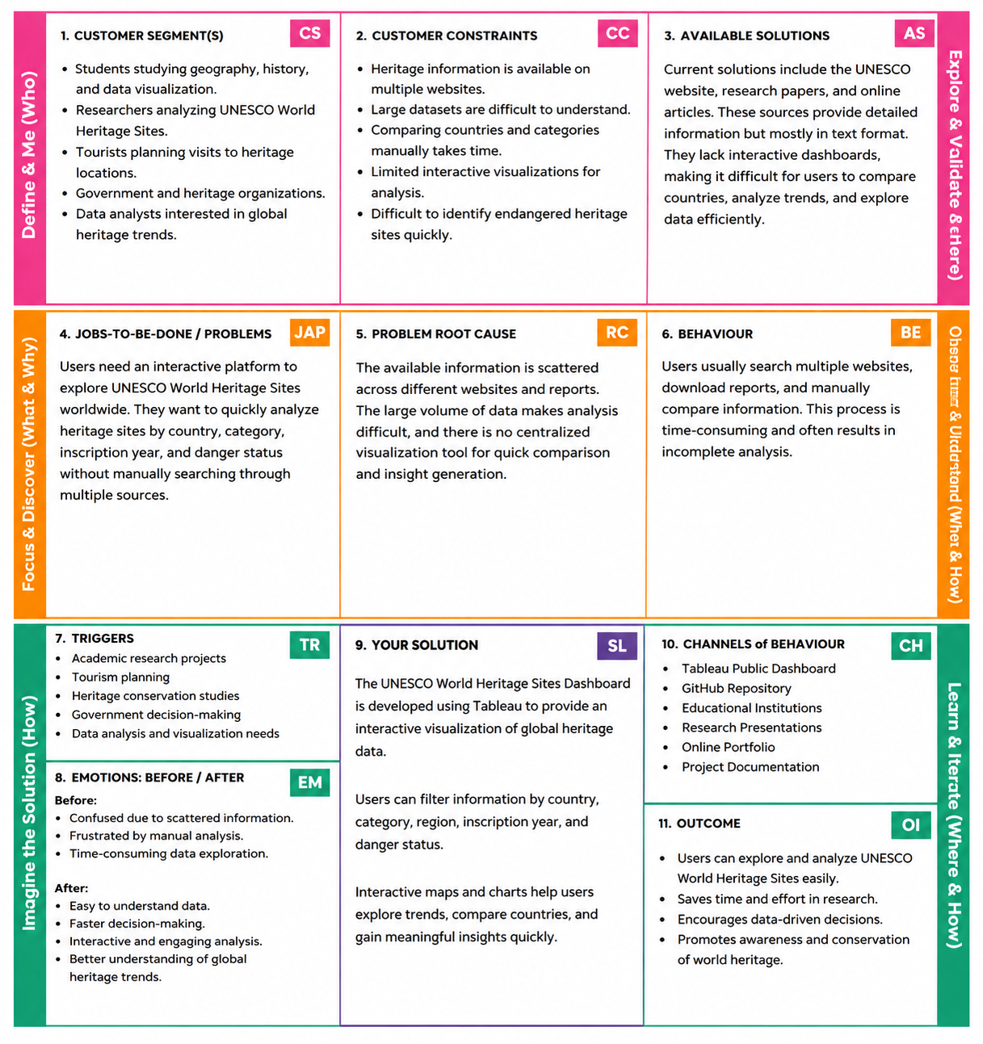
The Problem–Solution Fit Canvas identifies the target users, their challenges, existing solutions, and how the proposed Tableau dashboard addresses these problems through interactive data visualization and analysis of UNESCO World Heritage Sites.

